**Azure DevOps – Banking Application**

**PART 1 - Work Item Breakdown:**

**Epic:**

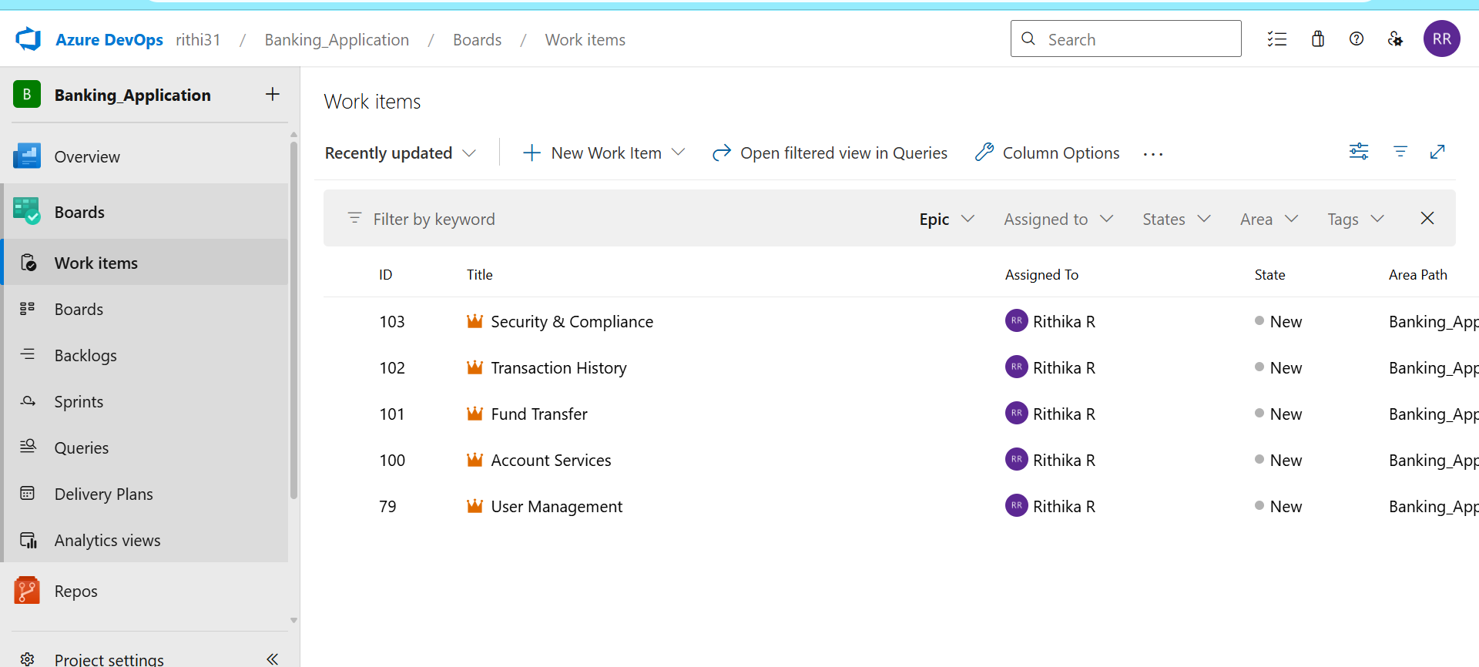

**Features:**

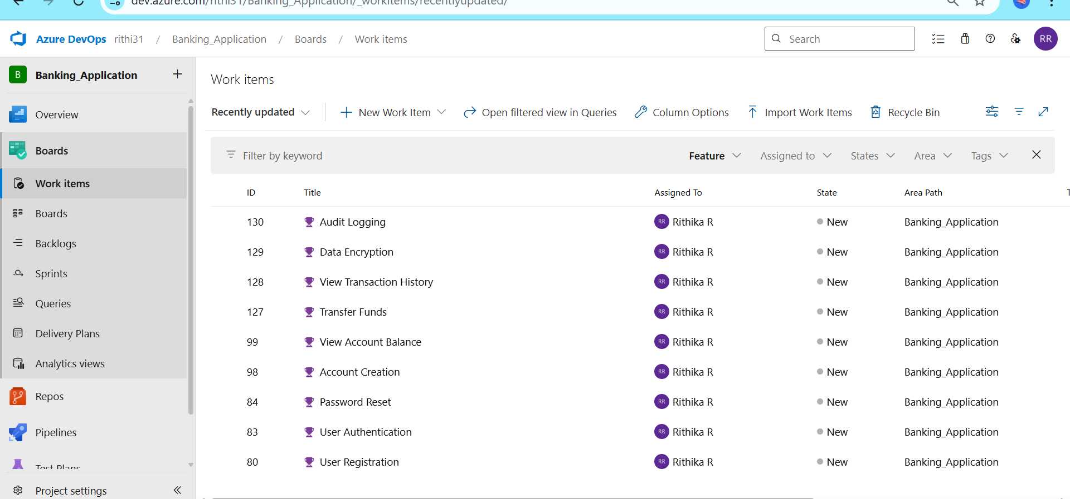

**User Story:**

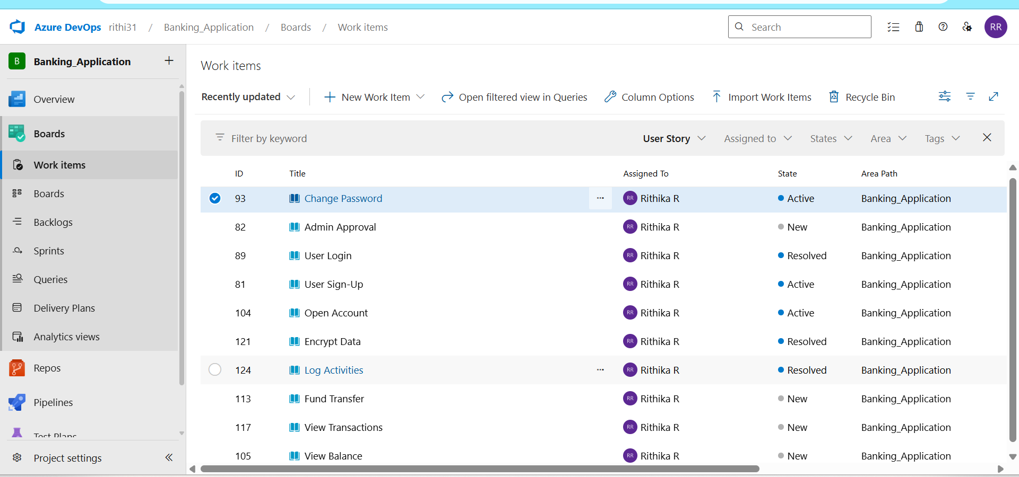

**Tasks**

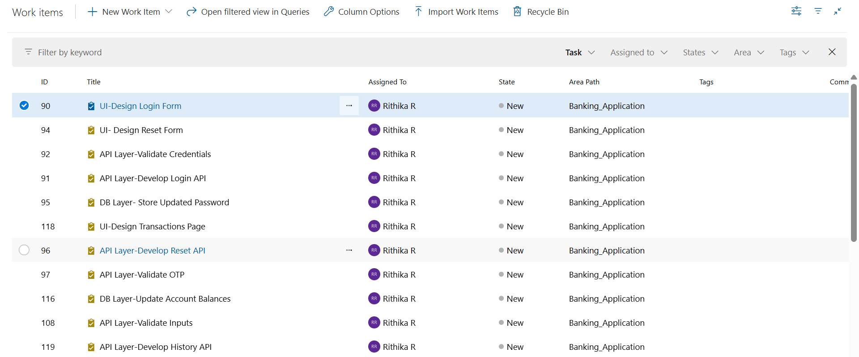

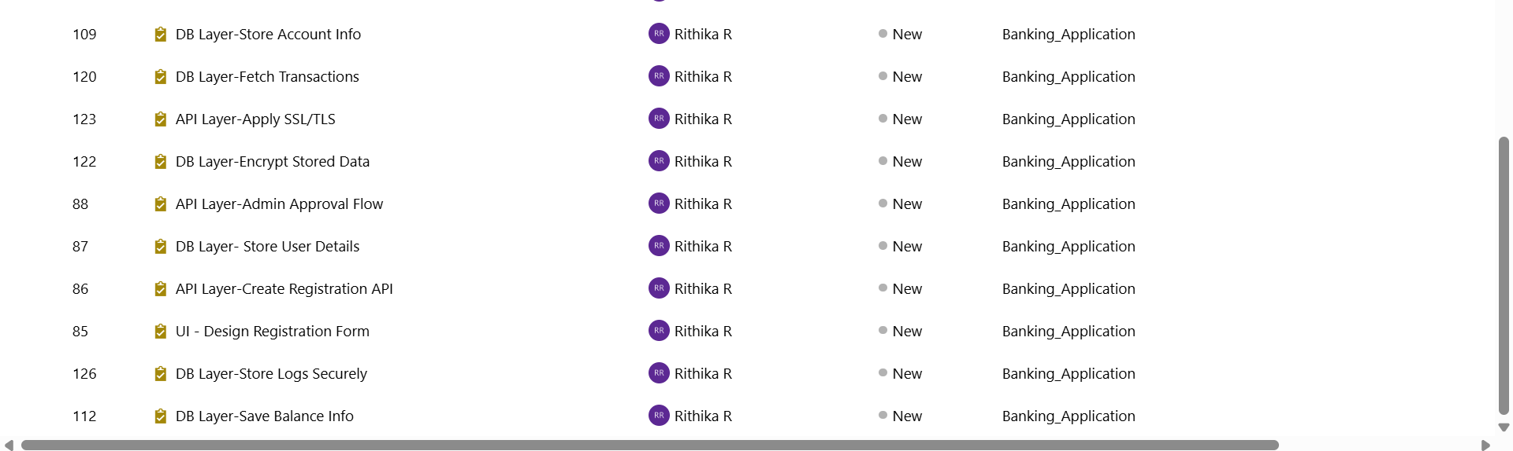

**Board:**

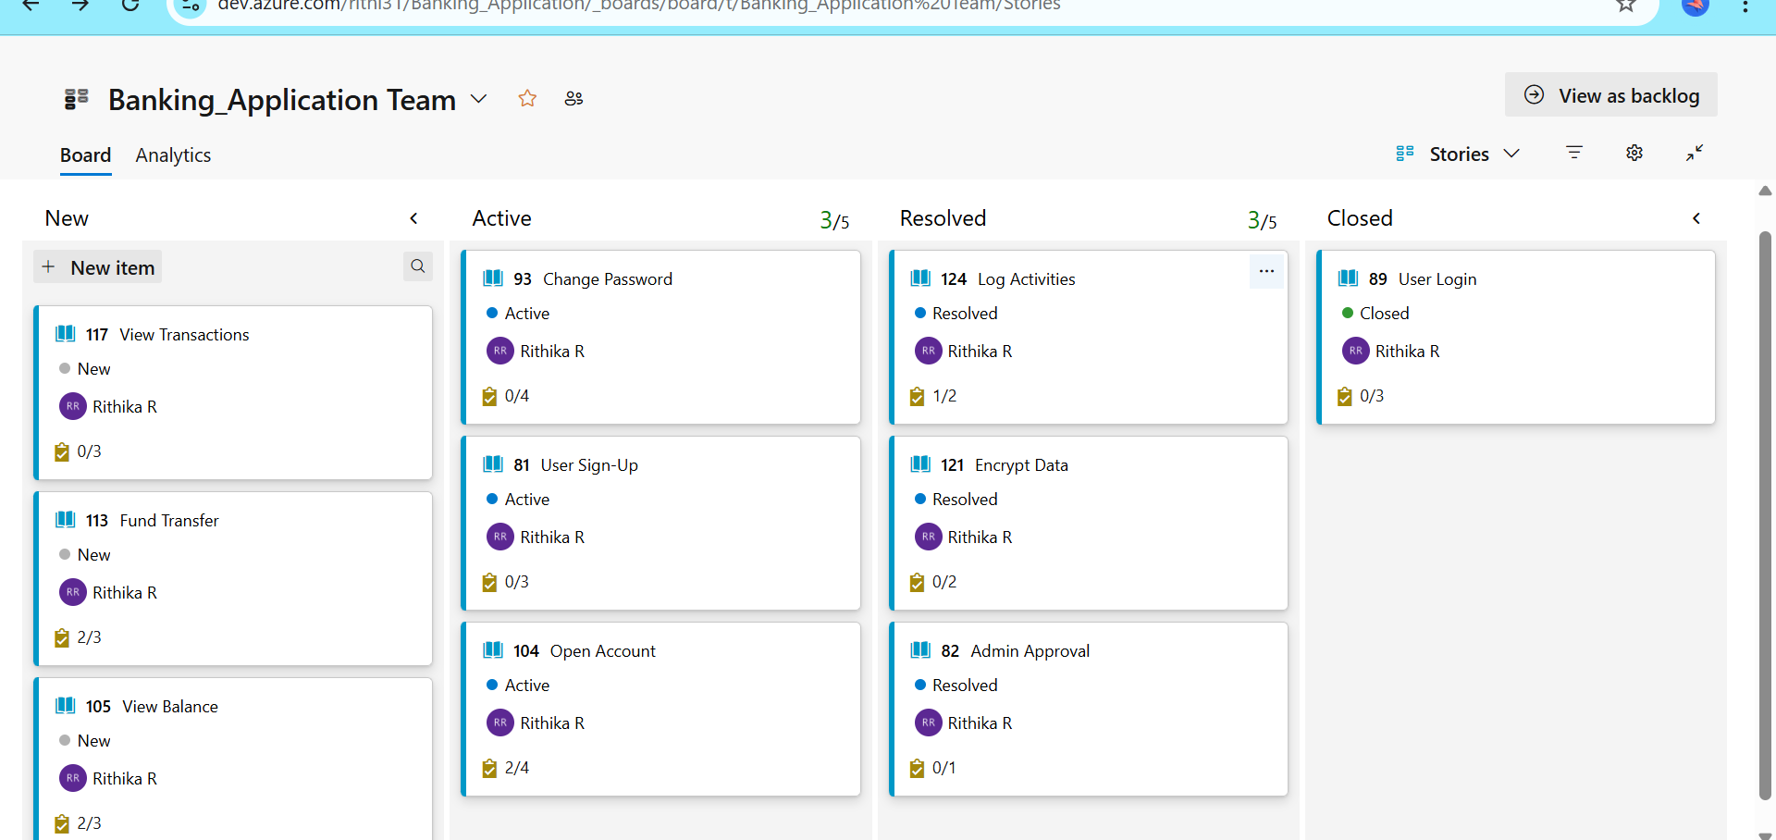

**Backlog:**

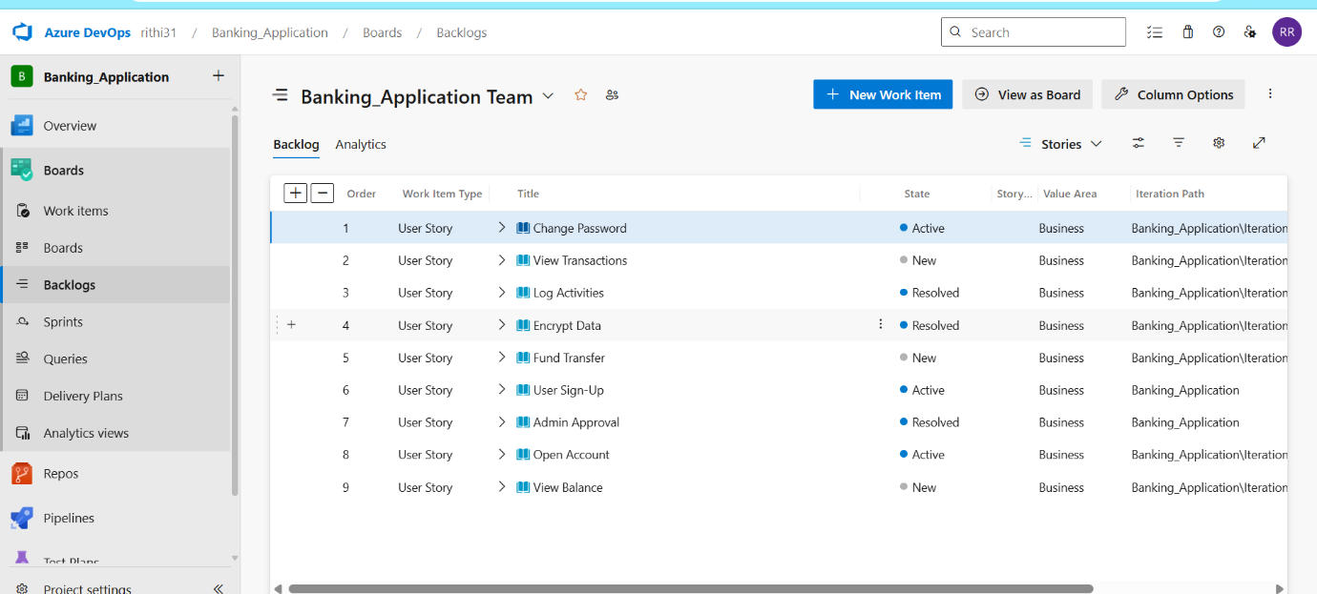

**PART 2 - Azure DevOps Git Setup**

1. Create a Git Repo Azure DevOps → Repos → New Repository → Banking-Application
2. Clone the repo locally or use portal
3. Add a project structure

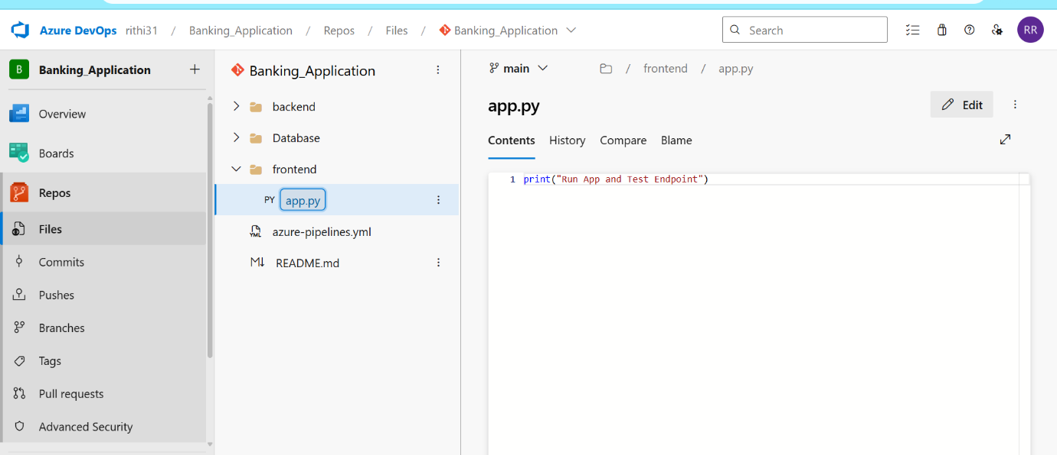

**PART 3 - Configure CI/CD Pipeline:**

azure-pipeline.yml:

trigger:

- main

pool:

vmImage: 'ubuntu-latest'

steps:

- task: UsePythonVersion@0

inputs:

versionSpec: '3.x'

displayName: 'Use Python 3'

- script: |

cd frontend

python -m venv venv

source venv/bin/activate

pip install -r requirements.txt

displayName: 'Install Dependencies'

- script: |

cd frontend

python app.py &

sleep 5 # Let app start for a while (simulate app running)

curl http://localhost:5000

displayName: 'Run App and Test Endpoint'

1. Go to your **Azure DevOps project**
2. Click **Pipelines → Create Pipeline**
3. Choose:
   * **Azure Repos Git**
   * Select your repository
   * **"Existing Azure Pipelines YAML file"**
4. Choose:
   * Branch: main
   * Path: /azure-pipelines.yml
5. Click **Continue**, then **Run Pipeline**

